Introduction to Operating Systems
An Operating System (OS) serves as an intermediary between users and computer hardware. It manages hardware resources and provides essential services for application software. The primary functions of an OS include:
- Process Management: Handling the creation, scheduling, and termination of processes.
- Memory Management: Managing the allocation and deallocation of memory space as needed by programs.
- File Management: Organizing and controlling data storage and retrieval.
- Device Management: Overseeing input and output devices, ensuring they function correctly.
- Security and Access Control: Protecting data and resources from unauthorized access.
Operating systems are crucial for the efficient functioning of computer systems, providing a stable environment for applications to run.
Services of Operating Systems
Operating systems provide various services to users and applications, including:
- User Interface: Command-line or graphical interfaces for user interaction.
- Program Execution: Loading and executing programs.
- I/O Operations: Handling input and output operations.
- Error Detection and Handling: Monitoring for errors and managing them effectively.
- Resource Allocation: Allocating resources like CPU time and memory to processes.
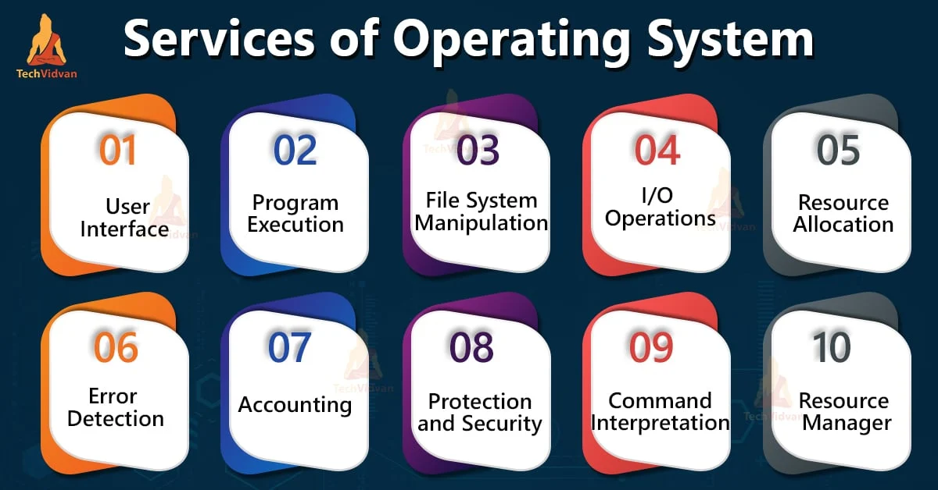
Need for Operating Systems
Operating systems are essential for:
- Resource Management: Efficiently managing hardware resources to maximize performance.
- User Convenience: Simplifying the interaction between users and hardware.
- System Security: Protecting the system from unauthorized access and ensuring data integrity.
What is Linux?
Linux is a free and open-source operating system based on Unix. It is known for its stability, security making it popular for servers, desktops, and embedded systems. Linux is designed to be compatible with Unix, providing similar functionalities.

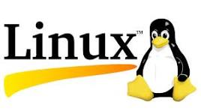

Need for Linux
- Open Source: Users can modify and distribute the source code, fostering innovation and collaboration.
- Cost-Effective: Being free, it reduces software licensing costs.

Services of Linux
Linux provides various services similar to other operating systems, including:
- Multi-user capabilities: Allowing multiple users to access the system simultaneously. - Multitasking: Running multiple processes at the same time.
- Networking: Comprehensive networking capabilities for connecting to other systems.
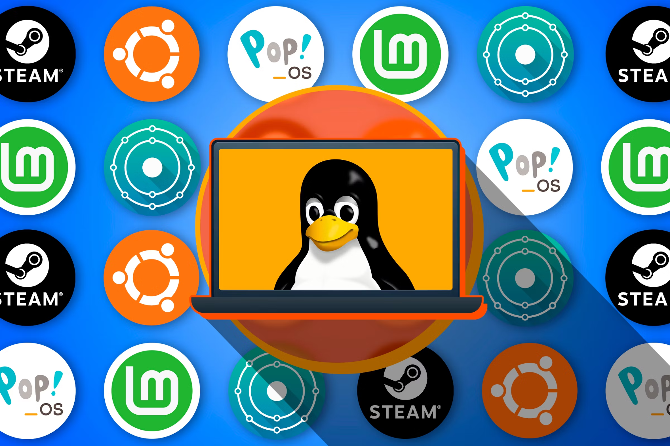
History of Linux
Linux was created by Linus Torvalds in 1991 as a personal project to develop a free operating system kernel. It has since grown into a robust platform supported by a vast community. Key milestones include:
- 1991: Initial release of the Linux kernel.
- 1992: Linux became a fully functional operating system.
- 1996: The first commercial distributions were released, paving the way for widespread adoption.
Linux Distributions
Linux is available in various distributions (distros), each tailored for specific needs. Some popular distributions include:
- Ubuntu: User-friendly and widely used for desktops.
- CentOS: Known for stability, often used in server environments.
- Debian: Renowned for its robustness and extensive package management.
- Fedora: Features the latest technologies and innovations.